Project Development Phase Sprint II

|  |  |
| --- | --- |
| Date | 19th November 2022 |
| Team ID | PNT2022TMID277860 |
| Project Name | Signs with Smart Connectivity for better road safety |

**SPRINT TARGETS:**

|  |  |  |  |  |  |  |
| --- | --- | --- | --- | --- | --- | --- |
| **Sprint** | **Functional Requirement (Epic)** | **UserStory Number** | **User Story / Task** | **Story Points** | **Priority** | **Team Members** |
| Sprint-2 | Aviod accidents  And speed control | USN-1 | Using smart digital signs and control speed limit | 20 | Medium | RAJESH  NAWAS  SAMUEL  MANI  BALAJI |

**Wokwi Simulation**: https://wokwi.com/projects/348855035785904723

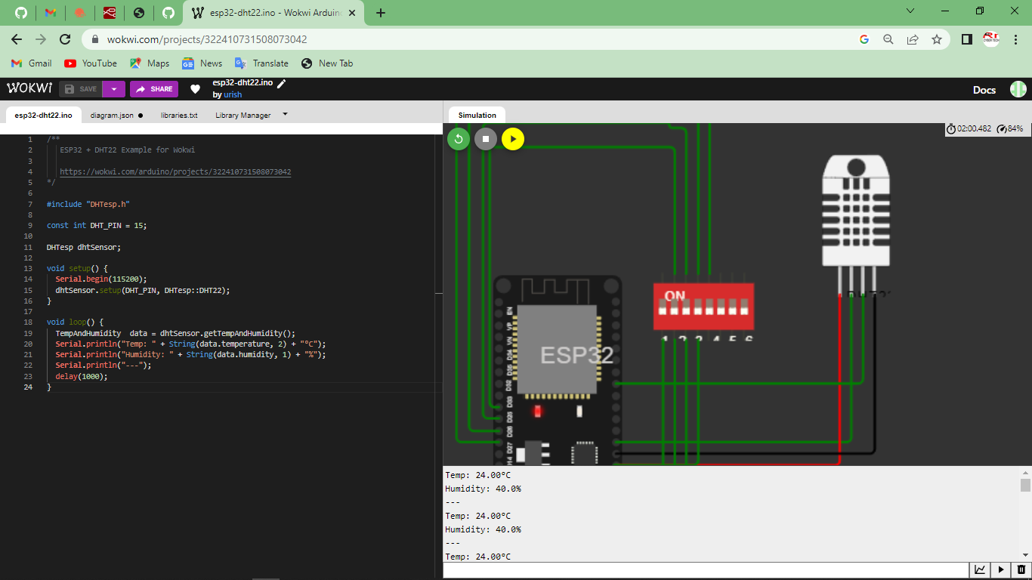

**IoT Device – IoT Platform**

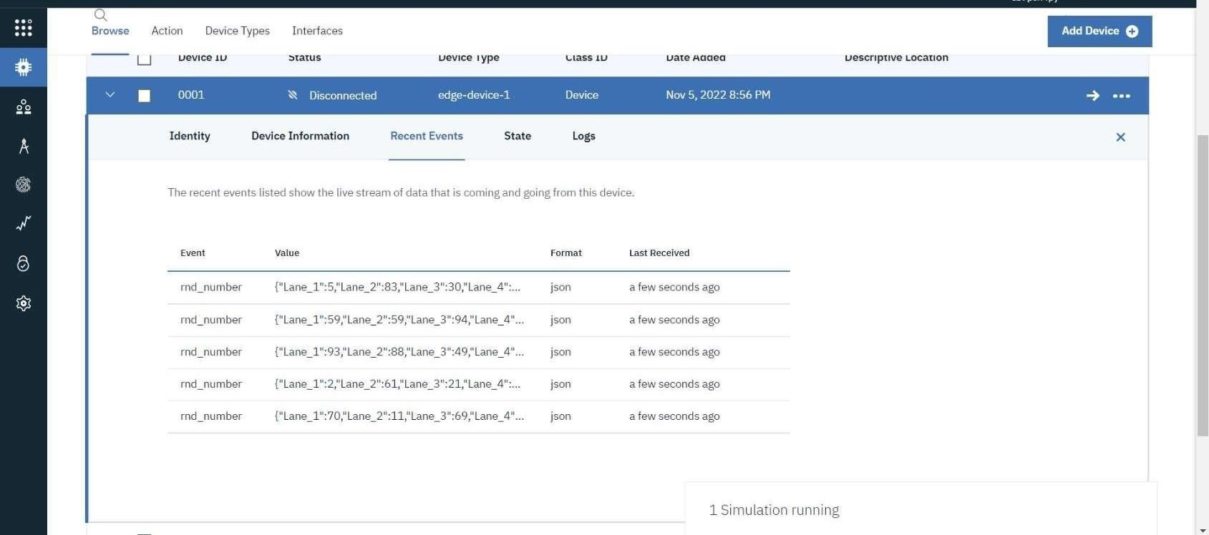

**Node Red**

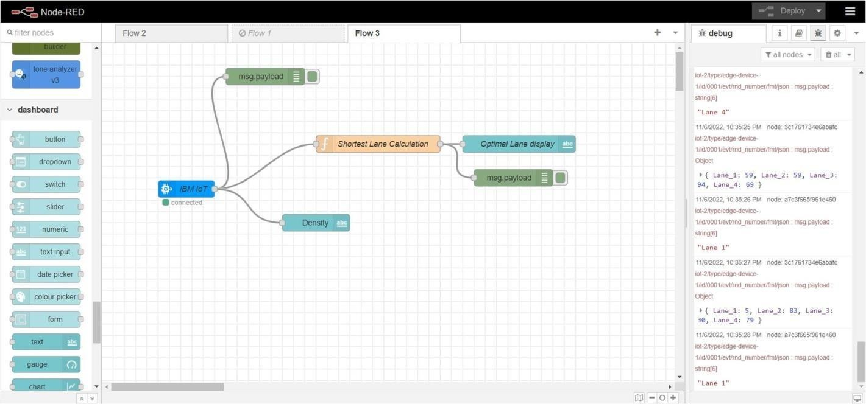

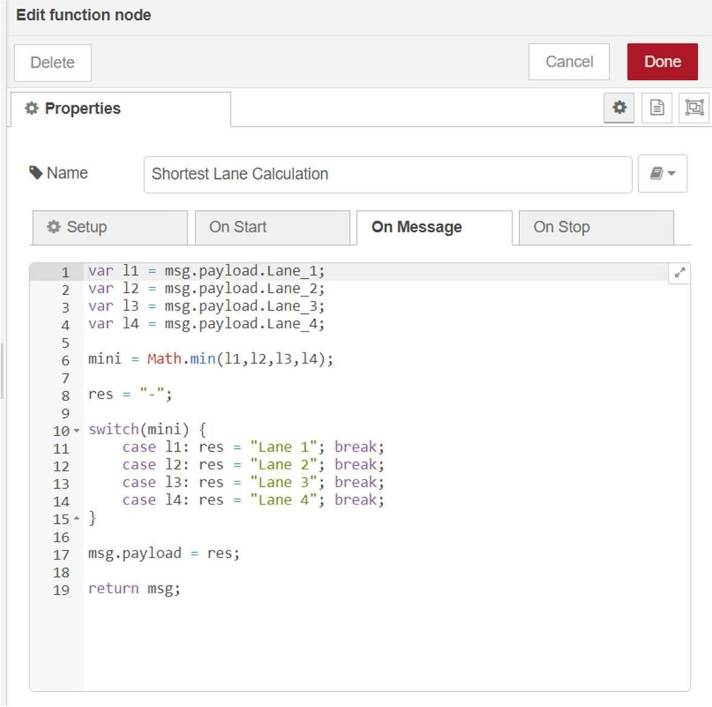

Node Red Web UI

